**Object Oriented Programming using C++**

**Project Report**

on

‘Flight reservation’

**Submitted to Punjab Technical University, Jalandhar**

**In partial fulfillment of the requirements for the degree of**

B. Tech in Computer Science & Engineering (Batch 2022-2026)

**Submitted To: Submitted By:**

**Ms. Pratibha Soram Pearl Dhawan (RollNo 2230070)**

**Pritha Rai (Roll No 2230078)**

**Dickens Kapalo (Roll No 2230004)**

**B. Tech 2A**

**PCTE INSTITUTE OF ENGINEERING & TECHNOLOGY, LUDHIANA**

# FEATURES OF THE PROJECT

1. Users can enter their personal information such as name, age, address, and gender.

2. Each customer is assigned a unique ID (cId).

3. Users can choose from a list of destinations and view available flights for each destination.

4. Flight details include flight numbers, departure dates, departure times, duration, and corresponding charges.

5. Users can select a specific flight for their chosen destination and book it.

6. The system calculates and displays the charges for the selected flight.

7. After booking a flight, the system generates a ticket with essential details, including customer information, destination and flight charges

8. The ticket is stored in a text file ("records.txt").

9. Users can view their generated ticket by choosing the relevant option in the main menu.

10. The system reads the ticket information from the file and displays it to the user.

**2. OUTPUT**

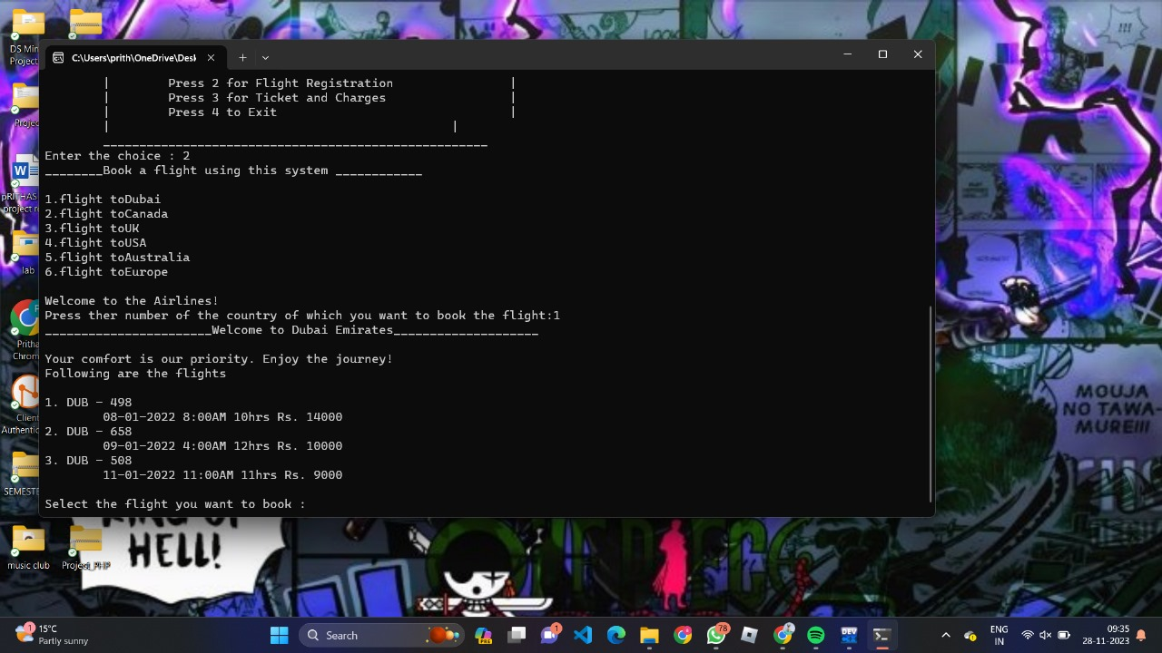

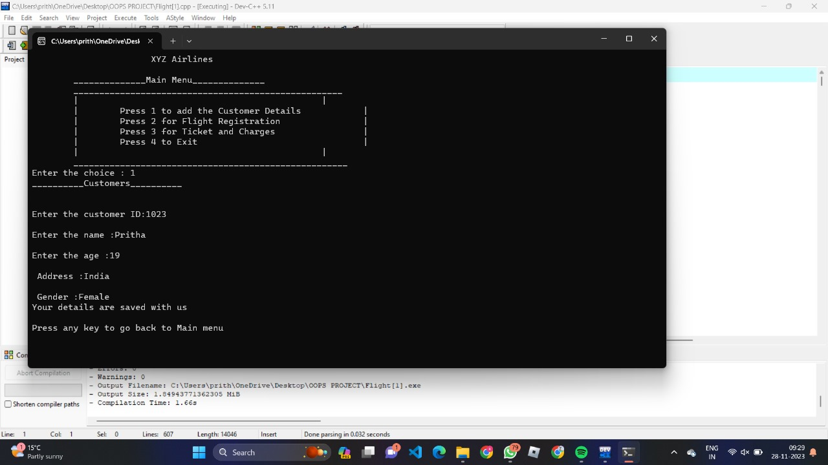

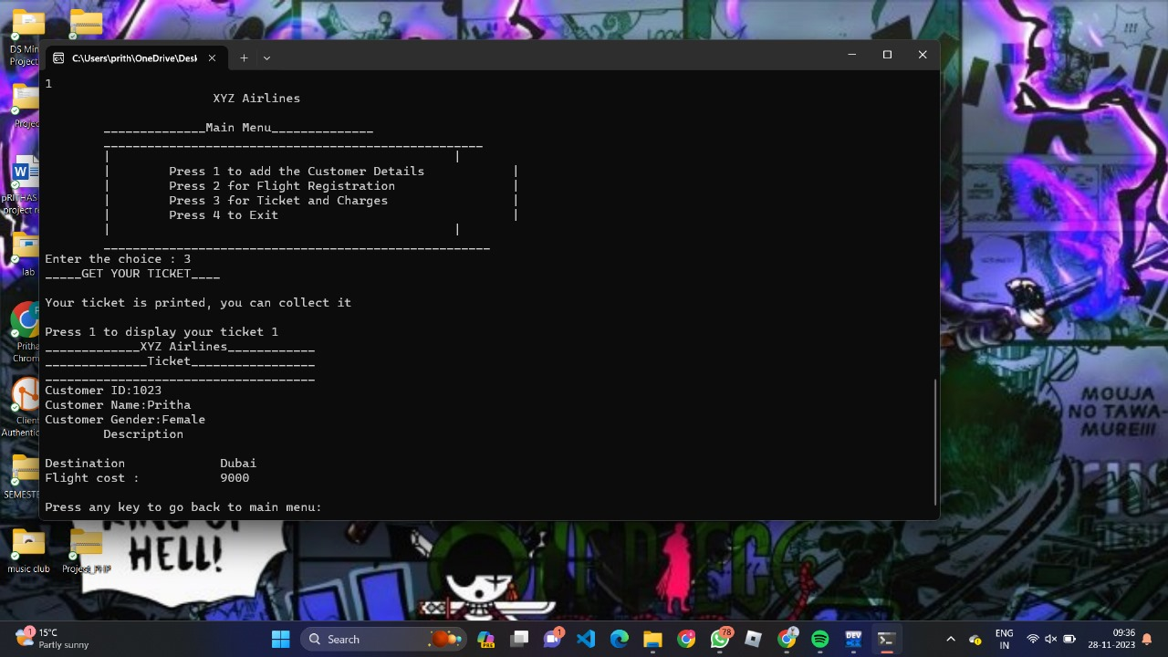

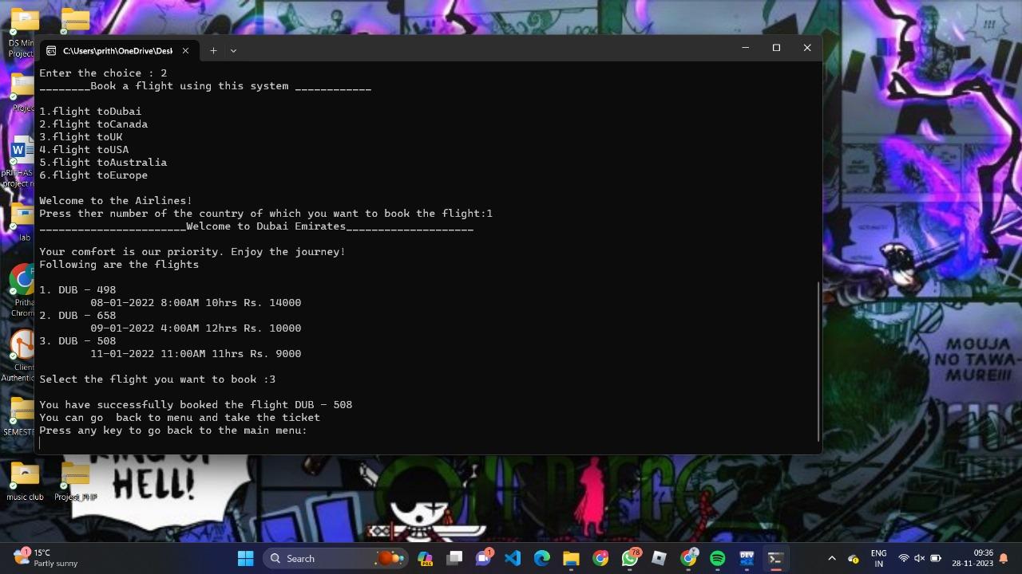

**3. CODE**

#include<iostream>

#include<fstream>

#include<iomanip>

using namespace std;

void mainMenu();

class Management

{

public:

Management()

{

mainMenu();

}

};

class Details

{

public:

static string name, gender;

int phoneNo;

int age;

string add;

static int cId;

char arr[100];

void information()

{

cout<<"\nEnter the customer ID:";

cin>>cId;

cout<<"\nEnter the name :";

cin>>name;

cout<<"\nEnter the age :";

cin>>age;

cout<<"\n Address :";

cin>>add;

cout<<"\n Gender :";

cin>>gender;

cout<<"Your details are saved with us\n"<<endl;

}

};

int Details::cId;

string Details::name;

string Details::gender;

class registration

{

public:

static int choice;

int choice1;

int back;

static float charges;

void flights()

{

string flightN[]={"Dubai","Canada","UK","USA","Australia","Europe"};

for(int a=0;a<6;a++)

{

cout<<(a+1)<<".flight to"<<flightN[a]<<endl;

}

cout<<"\nWelcome to the Airlines!"<<endl;

cout<<"Press ther number of the country of which you want to book the flight:";

cin>>choice;

switch(choice)

{

case 1:

{

cout<<"_______________________Welcome to Dubai Emirates____________________\n"<<endl;

cout<<"Your comfort is our priority. Enjoy the journey!"<<endl;

cout<<"Following are the flights \n"<<endl;

cout<<"1. DUB - 498"<<endl;

cout<<"\t08-01-2022 8:00AM 10hrs Rs. 14000"<<endl;

cout<<"2. DUB - 658"<<endl;

cout<<"\t09-01-2022 4:00AM 12hrs Rs. 10000"<<endl;

cout<<"3. DUB - 508"<<endl;

cout<<"\t11-01-2022 11:00AM 11hrs Rs. 9000"<<endl;

cout<<"\nSelect the flight you want to book :";

cin>>choice1;

if(choice1==1)

{

charges=14000;

cout<<"\nYou have successfully booked the flight DUB - 498"<<endl;

cout<<"You can go back to menu and take the ticket"<<endl;

}

else if(choice1==2)

{

charges=10000;

cout<<"\nYou have successfully booked the flight DUB - 658"<<endl;

cout<<"You can go back to menu and take the ticket"<<endl;

}

else if(choice1==3)

{

charges=9000;

cout<<"\nYou have successfully booked the flight DUB - 508"<<endl;

cout<<"You can go back to menu and take the ticket"<<endl;

}

else

{

cout<<"Invalid input , shifting to the previous menu"<<endl;

flights();

}

cout<<"Press any key to go back to the main menu:"<<endl;

cin>>back;

if(back==1)

{

mainMenu();

}

else

{

mainMenu();

}

}

case 2:

{

cout<<"_______________________Welcome to Canadian Airlines____________________\n"<<endl;

cout<<"Your comfort is our priority. Enjoy the journey!"<<endl;

cout<<"Following are the flights \n"<<endl;

cout<<"1. CA - 198"<<endl;

cout<<"\t09-01-2022 2:00PM 20hrs Rs. 34000"<<endl;

cout<<"2. CA - 158"<<endl;

cout<<"\t11-01-2022 6:00AM 23hrs Rs. 29000"<<endl;

cout<<"3. CA - 208"<<endl;

cout<<"\t14-01-2022 12:00AM 21hrs Rs. 40000"<<endl;

cout<<"\nSelect the flight you want to book :";

cin>>choice1;

if(choice1==1)

{

charges=34000;

cout<<"\nYou have successfully booked the flight CA - 198"<<endl;

cout<<"You can go back to menu and take the ticket"<<endl;

}

else if(choice1==2)

{

charges=29000;

cout<<"\nYou have successfully booked the flight CA - 158"<<endl;

cout<<"You can go back to menu and take the ticket"<<endl;

}

else if(choice1==3)

{

charges=40000;

cout<<"\nYou have successfully booked the flight CA - 208"<<endl;

cout<<"You can go back to menu and take the ticket"<<endl;

}

else

{

cout<<"Invalid input , shifting to the previous menu"<<endl;

flights();

}

cout<<"Press any key to go back to the main menu:"<<endl;

cin>>back;

if(back==1)

{

mainMenu();

}

else

{

mainMenu();

}

}

case 3:

{

cout<<"_______________________Welcome to UK Airways____________________\n"<<endl;

cout<<"Your comfort is our priority. Enjoy the journey!"<<endl;

cout<<"Following are the flights \n"<<endl;

cout<<"1. UK - 798"<<endl;

cout<<"\t12-01-2022 10:00AM 14hrs Rs. 44000"<<endl;

cout<<"\nSelect the flight you want to book :";

cin>>choice1;

if(choice1==1)

{

charges=44000;

cout<<"\nYou have successfully booked the flight UK - 798"<<endl;

cout<<"You can go back to menu and take the ticket"<<endl;

}

else

{

cout<<"Invalid input , shifting to the previous menu"<<endl;

flights();

}

cout<<"Press any key to go back to the main menu:"<<endl;

cin>>back;

if(back==1)

{

mainMenu();

}

else

{

mainMenu();

}

}

case 4:

{

cout<<"_______________________Welcome to US Airways____________________\n"<<endl;

cout<<"Your comfort is our priority. Enjoy the journey!"<<endl;

cout<<"Following are the flights \n"<<endl;

cout<<"1. US - 567"<<endl;

cout<<"\t10-01-2022 9:00AM 22hrs Rs. 37000"<<endl;

cout<<"2. US - 658"<<endl;

cout<<"\t09-01-2022 6:00AM 22hrs Rs. 39000"<<endl;

cout<<"3. US - 508"<<endl;

cout<<"\t12-01-2022 10:00AM 21hrs Rs. 42000"<<endl;

cout<<"\nSelect the flight you want to book :";

cin>>choice1;

if(choice1==1)

{

charges=37000;

cout<<"\nYou have successfully booked the flight US - 658"<<endl;

cout<<"You can go back to menu and take the ticket"<<endl;

}

else if(choice1==2)

{

charges=39000;

cout<<"\nYou have successfully booked the flight DUB - 658"<<endl;

cout<<"You can go back to menu and take the ticket"<<endl;

}

else if(choice1==3)

{

charges=42000;

cout<<"\nYou have successfully booked the flight DUB - 508"<<endl;

cout<<"You can go back to menu and take the ticket"<<endl;

}

else

{

cout<<"Invalid input , shifting to the previous menu"<<endl;

flights();

}

cout<<"Press any key to go back to the main menu:"<<endl;

cin>>back;

if(back==1)

{

mainMenu();

}

else

{

mainMenu();

}

}

case 5:

{

cout<<"_______________________Welcome to Australian Airlines____________________\n"<<endl;

cout<<"Your comfort is our priority. Enjoy the journey!"<<endl;

cout<<"Following are the flights \n"<<endl;

cout<<"1. As - 698"<<endl;

cout<<"\t018-01-2022 9:00AM 20hrs Rs. 44000"<<endl;

cout<<"2. AS - 158"<<endl;

cout<<"\t019-01-2022 4:00AM 22hrs Rs. 34000"<<endl;

cout<<"3. AS - 708"<<endl;

cout<<"\t17-01-2022 10:00AM 21hrs Rs. 42000"<<endl;

cout<<"\nSelect the flight you want to book :";

cin>>choice1;

if(choice1==1)

{

charges=44000;

cout<<"\nYou have successfully booked the flight DUB - 498"<<endl;

cout<<"You can go back to menu and take the ticket"<<endl;

}

else if(choice1==2)

{

charges=34000;

cout<<"\nYou have successfully booked the flight DUB - 658"<<endl;

cout<<"You can go back to menu and take the ticket"<<endl;

}

else if(choice1==3)

{

charges=42000;

cout<<"\nYou have successfully booked the flight DUB - 508"<<endl;

cout<<"You can go back to menu and take the ticket"<<endl;

}

else

{

cout<<"Invalid input , shifting to the previous menu"<<endl;

flights();

}

cout<<"Press any key to go back to the main menu:"<<endl;

cin>>back;

if(back==1)

{

mainMenu();

}

else

{

mainMenu();

}

}

case 6:

{

cout<<"_______________________Welcome to European Airlines____________________\n"<<endl;

cout<<"Your comfort is our priority. Enjoy the journey!"<<endl;

cout<<"Following are the flights \n"<<endl;

cout<<"1. EU - 898"<<endl;

cout<<"\t02-01-2022 2:00AM 18hrs Rs. 36000"<<endl;

cout<<"2. EU - 958"<<endl;

cout<<"\t03-01-2022 6:00AM 19hrs Rs. 37000"<<endl;

cout<<"3. EU - 608"<<endl;

cout<<"\t12-01-2022 10:00AM 20hrs Rs. 31000"<<endl;

cout<<"\nSelect the flight you want to book :";

cin>>choice1;

if(choice1==1)

{

charges=36000;

cout<<"\nYou have successfully booked the flight EU - 898"<<endl;

cout<<"You can go back to menu and take the ticket"<<endl;

}

else if(choice1==2)

{

charges=37000;

cout<<"\nYou have successfully booked the flight EU - 958"<<endl;

cout<<"You can go back to menu and take the ticket"<<endl;

}

else if(choice1==3)

{

charges=31000;

cout<<"\nYou have successfully booked the flight EU - 608"<<endl;

cout<<"You can go back to menu and take the ticket"<<endl;

}

else

{

cout<<"Invalid input , shifting to the previous menu"<<endl;

flights();

}

cout<<"Press any key to go back to the main menu:"<<endl;

cin>>back;

if(back==1)

{

mainMenu();

}

else

{

mainMenu();

}

}

default :

{

cout<<"Invalid input, Shifting you to the main menu !"<<endl;

mainMenu();

break;

}

}

}

};

float registration::charges;

int registration::choice;

class ticket : public registration, Details

{

public:

void Bill()

{

string destination="";

ofstream outf("records.txt");

{

outf<<"_____________XYZ Airlines____________"<<endl;

outf<<"______________Ticket_________________"<<endl;

outf<<"_____________________________________"<<endl;

outf<<"Customer ID:"<<Details::cId<<endl;

outf<<"Customer Name:"<<Details::name<<endl;

outf<<"Customer Age:"<<Details::age<<endl;

outf<<"Customer Gender:"<<Details::gender<<endl;

outf<<"\tDescription"<<endl<<endl;

if(registration::choice==1)

{

destination="Dubai";

}

else if(registration::choice==2)

{

destination="Canada";

}

else if(registration::choice==3)

{

destination="UK";

}

else if(registration::choice==4)

{

destination="USA";

}

else if(registration::choice==5)

{

destination="Australia";

}

else if(registration::choice==6)

{

destination="Europe";

}

outf<<"Destination\t\t"<<destination<<endl;

outf<<"Flight cost :\t\t"<<registration::charges<<endl;

}

outf.close();

}

void dispBill()

{

ifstream ifs("records.txt");

{

if(!ifs)

{

cout<<"File error!"<<endl;

}

while(!ifs.eof())

{

ifs.getline(arr, 100);

cout<<arr<<endl;

}

}

ifs.close();

}

};

void mainMenu()

{

int lchoice;

int schoice;

int back;

cout<<"\t XYZ Airlines \n"<<endl;

cout<<"\t______________Main Menu______________"<<endl;

cout<<"\t____________________________________________________"<<endl;

cout<<"\t|\t\t\t\t\t\t|" <<endl;

cout<<"\t|\t Press 1 to add the Customer Details \t|"<<endl;

cout<<"\t|\t Press 2 for Flight Registration \t|"<<endl;

cout<<"\t|\t Press 3 for Ticket and Charges \t|"<<endl;

cout<<"\t|\t Press 4 to Exit \t|"<<endl;

cout<<"\t|\t\t\t\t\t\t|" <<endl;

cout<<"\t_____________________________________________________"<<endl;

cout<<"Enter the choice : ";

cin>>lchoice;

Details d;

registration r;

ticket t;

switch(lchoice)

{

case 1:

{

cout<<"__________Customers__________\n"<<endl;

d.information();

cout<<"Press any key to go back to Main menu ";

cin>>back;

if(back==1)

{

mainMenu();

}

else

{

mainMenu();

}

break;

}

case 2:

{

cout<<"________Book a flight using this system ____________\n"<<endl;

r.flights();

break;

}

case 3:

{

cout<<"_____GET YOUR TICKET____\n"<<endl;

t.Bill();

cout<<"Your ticket is printed, you can collect it \n"<<endl;

cout<<"Press 1 to display your ticket ";

cin>>back;

if(back==1)

{

t.dispBill();

cout<<"Press any key to go back to main menu:";

cin>>back;

if(back==1)

{

mainMenu();

}

else

{

mainMenu();

}

}

else

{

mainMenu();

}

break;

}

case 4:

{

cout<<"\n\n\t_________Thank-you_______"<<endl;

break;

}

default :

{

cout<<"Invalid input, Please try again!\n"<<endl;

mainMenu();

break;

}

}

}

int main()

{

Management Mobj;

return 0;

}

**4. CONCLUSION**

In conclusion, a user-friendly flight reservation website should prioritize seamless navigation, clear information presentation, and a secure booking process to enhance the overall user experience and encourage repeat usage. Our project helps the user to navigate through the process of flight reservation with easy to understand features using classes, inheritances and file handling.

**References:**

[1] https://www.geeksforgeeks.org/file-handling-c-classes/

[2] https://www.geeksforgeeks.org/inheritance-in-c/

[3] https://www.simplilearn.com/tutorials/cpp-tutorial/classes-in-cpp